Linked-List Operations:
Insertion:
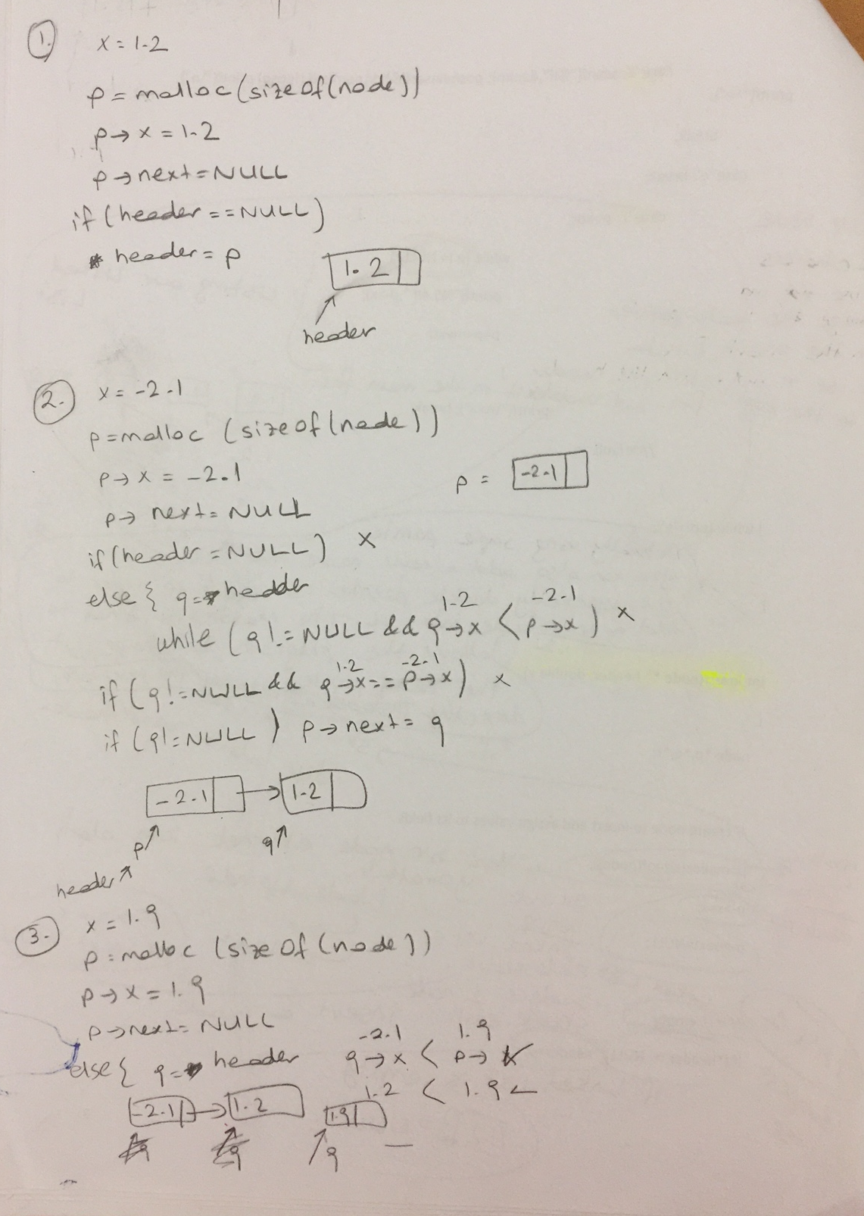
Search: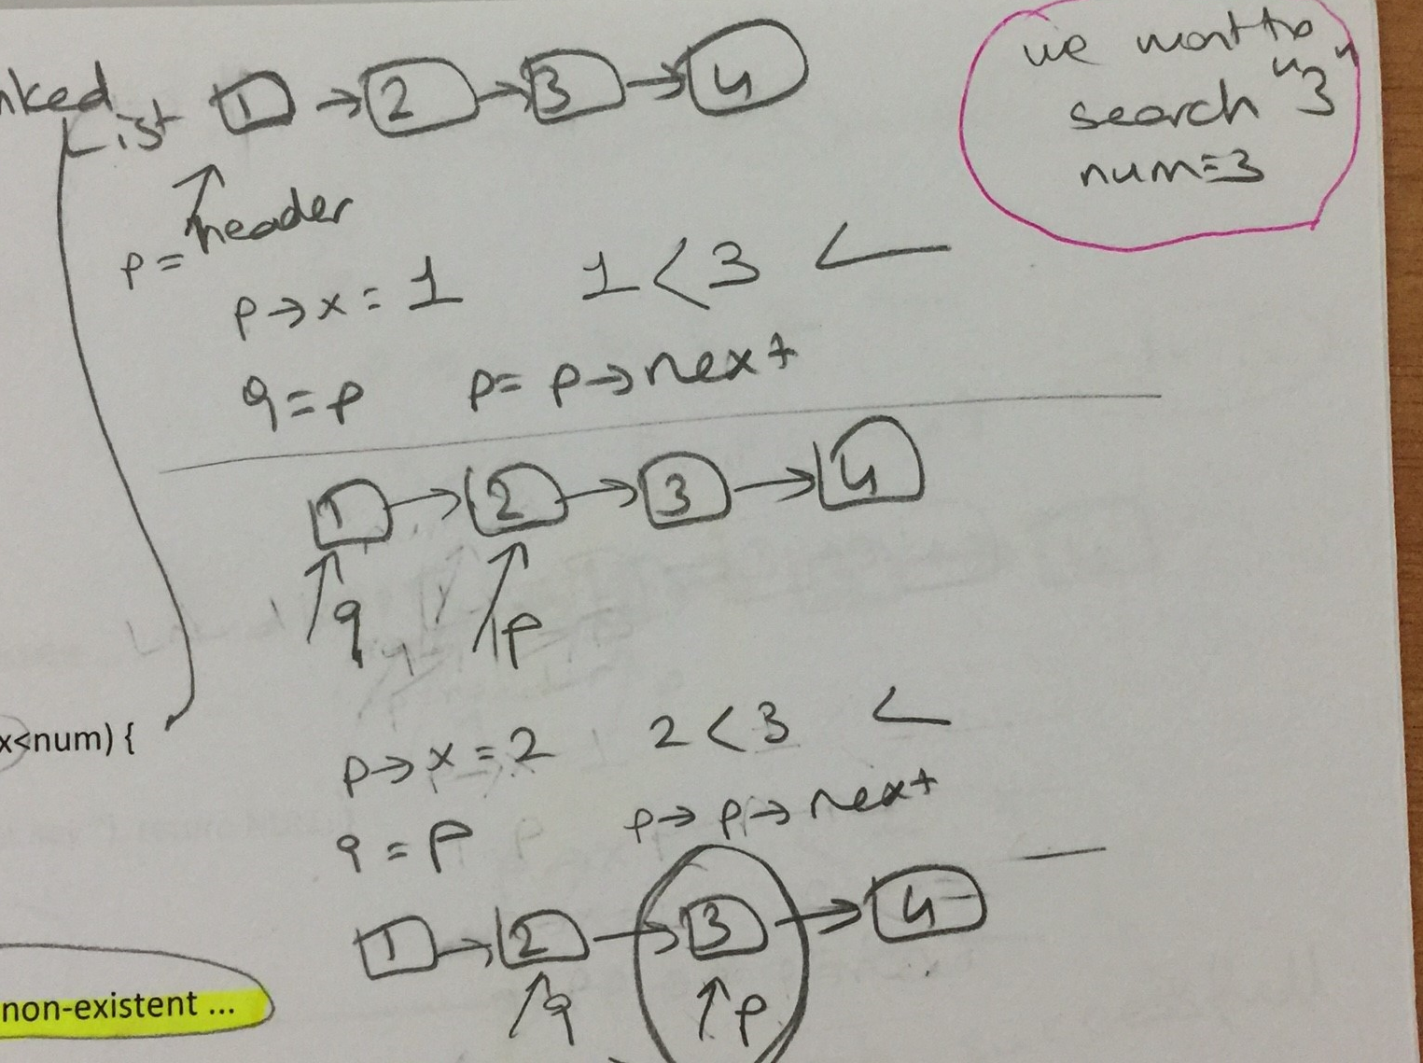

- (Quiz-2017) (6 pts)
What value does function mystery return when called with a value of 4?

int mystery ( int number )
{
if ( number <= 1 )
return 1;
else
return number * mystery( number – 1 );
}
Answer:24

- (Quiz-2017) What is the output of the following program?

main()
{
int a[] ={1,2,9,8,6,3,5,7,8,9};
int *p=a+1;
int *q=a+6;
printf("\n%d ", q-p);
}
5

- 2010-Midterm (15 pts)

Consider the data records R₁,...,R_{n}, and a program processing these data. Its access pattern to these data records is that each data record R_{i} is accessed n-i times. That is, R₁ is the most frequently accessed record (n-1 times) while R_{n} is the least frequently accessed one (only once).

Construct a linked list to keep these records in the main memory so as to minimize the total access time, where one time unit is the time taken to compare the key of a linked list with the key searched! Calculate the total access time for your linked list in terms of n!
R₁ -> R₂-> R₃-> R₄-> R₅-> … > R_{n}

- (2015-Quiz)Select the correct choice (4 pts)
An algorithm that requires __________ operations to complete its task on n data elements is said to have a linear runtime.
a. n³ + 9
b. 3 n² + 3 n + 2
c. 2 n + 1
d. 6

C
- (2015-Quiz)Select the correct choice (4 pts)
In general, linked lists allow:
a. Insertions and removals anywhere.
b. Insertions and removals only at one end.
c. Insertions at the back and removals from the front.
d. None of the above.

A
- 2013-Midterm (10 pts)

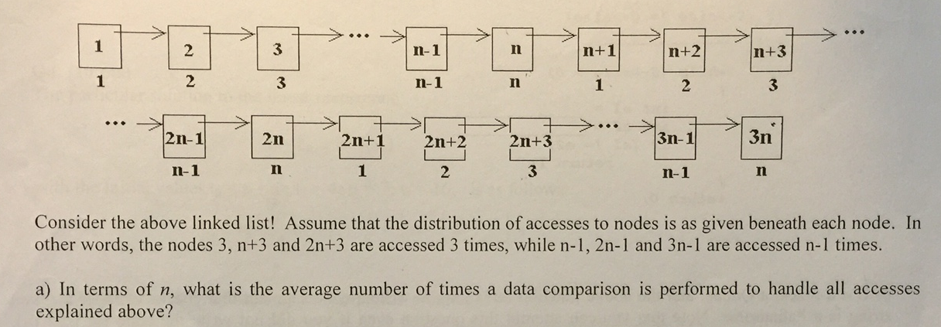

/ 3

7. 2011-Midterm(10pts)
Consider the algorithms A₁…A₅ solving the same problem with execution times, t₁(n),…,t₅(n), of the following asymptotic upper bounds. Put the algorithms in order regarding their execution speed from the fastest to the slowest!
- O(3^{n})
- O(n^{n})
- O(n2^{n})
- O(n!)
- O(log(n²n^{n}))
Solution:
O(log(n²n^{n})) = O(2log(n) + nlog(n)) = O(nlogn)
O(3^{n}) ?O(n!)
For instance; for n=10, 3¹⁰= 59 049 and 10!= 3 628 800)
O(nlogn)<O(3^{n})<O(n!)<O(n^{n})
O(n2^{n}) < O(3^{n})
n2^{n} < 3^{n}
Final ordering:
O(nlogn) < O(n2^{n}) < O(3^{n}) < O(n!) < O(n^{n})

